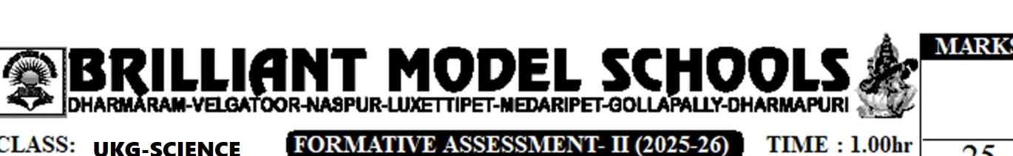
CLASS: UKG-SCIENCE
FORMATIVE ASSESSMENT- II (2025-26)
TIME : 1.00hr
MARKS
25
NAME:
Roll No:
I Answer the following Questions 5x3=15
1. How many hands and legs do you have?

2. What do you see with?

3. What kind of food should we eat?

4. What do you smell with?

5. Where should we play?

II Write the missing Letters. 5x½=2½
1. E ___ S
2. N ___ E
3. L ___ G
4. M ___ H
5. T ___ ___ H

III Complete the following. 5x1/2=21/2
1. I eat with my ___________ (Nose, Mouth).
2. Brush you ___________ daily.
3. Wear ___________ clothes.
4. I walk with my ___________ (Hands, Legs).
5. We should keep our body ___________.
IV Match the following. 5x1=5
1. Smell | 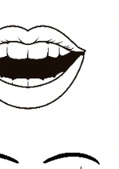none
2. Hair | 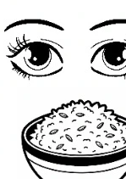none
3. Food | 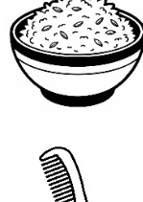none
4. See | 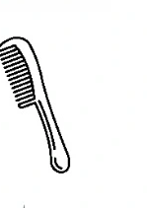none
5. Eat | 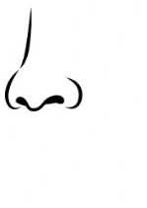none

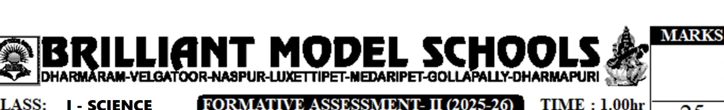
CLASS: I - SCIENCE
FORMATIVE ASSESSMENT- II (2025-26)
TIME : 1.00hr
MARKS
25
NAME: _________________________________
Roll No: ______________
I Answer the following Questions 4x3=12
1. Why do we need food?

2. Name the three types of plants?

3. Name any two roots that are eaten as vegetables?

4. How are these parts useful to the plant? Write any one of each part.
a) Stem : __________________________________________________________________
b) Seeds : _________________________________________________________________
II Choose the correct answer. 4x1=4
1. Leaves Make this for the plant.
a) Air ☐ b) Water ☐ c) Food ☐ [ ]
2. A big and strong plant is called this.
a) Herb ☐ b) Shrub ☐ c) Tree ☐ [ ]
3. Cereals and pulses are called this.
a) Food grain ☐ b) Spices ☐ c) Vegetables. ☐ [ ]
4. Coriander seeds are used as this.
a) Sweets ☐ b) Spices ☐ c) Nuts. ☐ [ ]

III Write 'T' for true, 'F' for false. 3x1=3
1. Herbs are small plants. [ ]
2. All parts of all plants can be eaten. [ ]
3. Seeds can grow into new plants [ ]
IV Match the following. 4x1=4
a) Coconut plant i) Has a few seeds
b) Pomegranate fruit ii) Herb
c) Orange fruit iii) Has many seeds
d) Mint plant iv) Tree
V Label the parts of the plant, Then colour the plant. 2x1=2
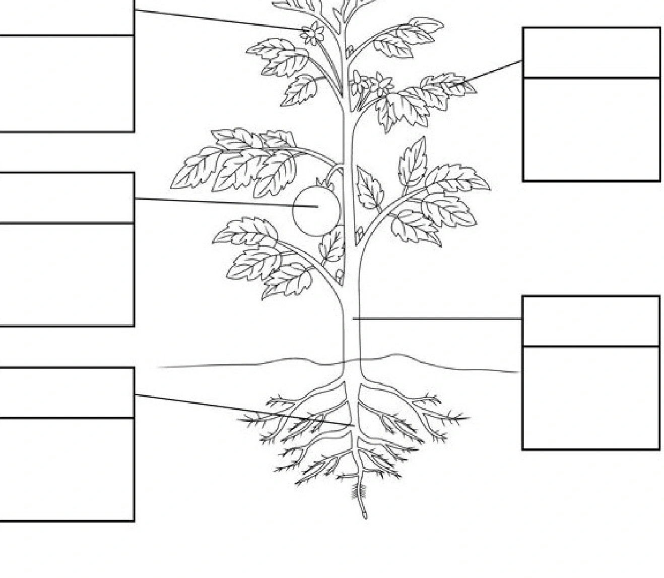 | [source image needs review]  _ | [source image needs review]  _ | [source image needs review]

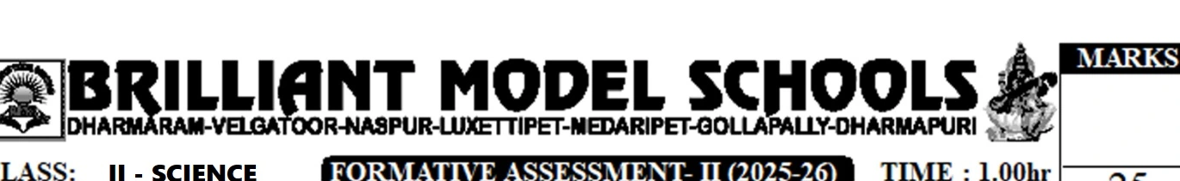
CLASS: II - SCIENCE
FORMATIVE ASSESSMENT- II (2025-26)
TIME : 1.00hr
MARKS
DHARMARAM-VELGATOOR-NASPUR-LUXETTIPET-MEDARIPET-GOLLAPALLY-DHARMAPURI
NAME: _________________________________ Roll No: _________ 25
I Answer the following Questions 4x3=12
1. What do we get from Silkworm?

2. Name any four milk products?

3. What are insects? Name an insect you have seen in your house.

4. What body parts helps frogs swim in water?

II Choose the correct answer. 5x1=5
5. ___________ (Silk worms/ Honey bees)make cocoons.
6. ___________ (Elephants / Dogs )help us carry things.
7. ___________ ( curd / Honey ) is a milk product.
8. Most ___________ ( birds / rats )can fly.
9. Rabbits live ___________ ( on land / in water)

III Choose the correct answer. | 5x1=5
1. We get honey from these | [ ]
a) Cocoons b) Beehives | c) Beeswax | d) Hens
2. We get wool from this animal | [ ]
a) Elephant b) Silkworm c) Sheep | d) Duck
3. Fish live here | [ ]
a) Water b) Land | c) Trees | d) Sky
4. Fish breathe with these | [ ]
a) Fins b) Gills | c) Scales | d) Tails
5. We use this to make butter | [ ]
a) Milk b) Egg | c) Honey | d) Meat
III Circle the odd one out. | 3x1=3
1. Cow | Horse | Buffalow
2. Wool | Honey | Silk
3. Hen | Duck | Sheep

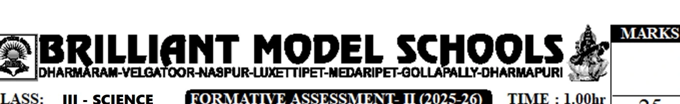
CLASS: III - SCIENCE
FORMATIVE ASSESSMENT- II (2025-26)
TIME : 1.00hr
MARKS
25
NAME: ____________________________________
Roll No: ___________
I Answer the following Questions 5x3=15
1. What is a food chain?

2. Name two animals that gnaw their food?

3. Name two flightless birds?

4. What is a nest? Why do birds build nests?

5. Write the names of any three organ systems found in our body?

II Fill in the blanks. 5x1/2=2 1/2
1. Birds that fly have ______________bones.
2. The duck has ______________ feet to help it swim in water.
3. The heart ______________blood.
4. The nervous system ________________ the functions of all the other organ systems.
5. The action done by organ systems is called the ________________ of organ systems.

1 1
III Choose the correct answer. | 5x /2 =2 /2
1.This animals has broad and flat teeth. | [ ]
a) Horse | b) Tiger | c) Lion | d) Eagle
2. This animals uses its long tongue to catch insects. | [ ]
a) Crocodile | b) Snake | c) Frog | d) Dog
3. Muscles are a part of this organ system. | [ ]
a) Digestive | b) Nervous | c) Skeletal | d) Muscular
4. Brain is a apart of this organ system. | [ ]
a) Circulatory b) Digestive | c) Excretory | d) Nervous.
5.Large intestine is a part of this organ system. | [ ]
a) Digestive | b) Nervous | c) Skeletal | d) Muscular
III Match the following. | 5x1=5
1. It has a pecking or drilling beak | a) Skin
2. It weaves its nest on branches of trees | b) Wind Pipe
3. This controls the body | c) Wearer bird
4. Air is taken to the lungs through this | d) Brain
5. This removes sweat from our body | e) Wood Peaker

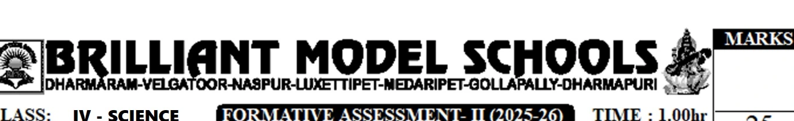
CLASS: IV - SCIENCE
FORMATIVE ASSESSMENT- II (2025-26)
TIME : 1.00hr
MARKS
25
NAME: _________________________________
Roll No: ______________
I Answer the following Questions 5x3=15
1. What is Incubation?

2. Describe the life cycle of a frog?

3. Name three animals that lay eggs and three that give birth to young ones.

4. What is Hibernation?

5. Name any three animal habitats?

II Fill in the blanks. 5x1/2=21/2
1. The egg of a hen has a yellow part called the ____________.
2. The female frog lays eggs in bunches called____________.
3. The egg of a hen is covered with a hard protective____________.
4. Camels have ____________ feet to walk easily on desert sand.
5. Carnivorous birds such as eagles have special claws called ____________.

1 1
III Choose the correct answer. | 5x /2 =2 /2
1.The larva of a butterfly is called this. | [ ]
a) Caterpillar | b) Egg | c) Case | d) Nymph
2. These are the stages through which an embryo develops into an adult. | [ ]
a) Life cycle | b) Hatching | c) Life span | d) Incubation
3. These animals live on land. | [ ]
a) Terrestrial b) Aerial | c) Arboreal | d) Aquatic
4. Animals that live mostly on trees are called this. | [ ]
a) Terrestrial | b) Aerial | c) Arboreal | d) Aquatic
5.This is the period of time for which a living organism lives from birth until death. | [ ]
a) Life cycle | b) Hatching | c) Life span | d) None of these
IV Write True (T) or False (F). | 5x1=5
1. The albumen is also called yolk . | [ ]
2. The yolk provides vitamins to the embryo inside the egg. | [ ]
3. Frogs and earth warm hibernate in summer. | [ ]
4. A Silk insect mimics a leaf. | [ ]
5. A Whale comes to the surface of the water to breathe air. | [ ]

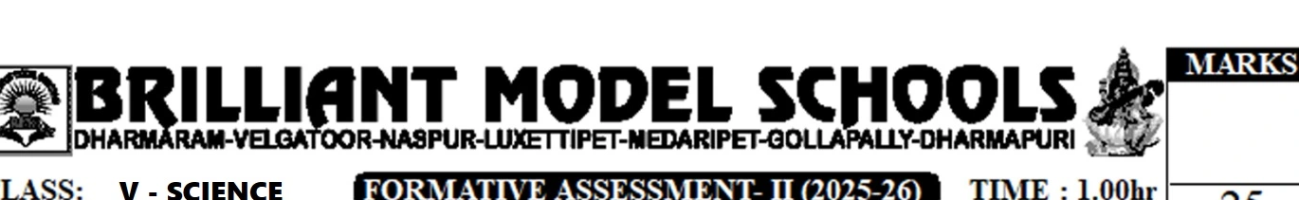
BRILLIANT MODEL SCHOOLS
DHARMARAM-VELGATOOR-NASPUR-LUXETTIPET-MEDARIPET-GOLLAPALLY-DHARMAPURI
CLASS: V - SCIENCE
FORMATIVE ASSESSMENT- II (2025-26)
TIME : 1.00hr
MARKS: 25
NAME: _________________________________
Roll No: _______________________________
I Answer the following Questions 5x3=15
1. What is Nutrient?

2. What is vaccination? How does it help us?

3. What are Vertebrae?

4. What is the skeletal system? Write any three functions of the skeletal system?

5. What is the nervous system?

1 1
II Fill in the blanks. | 5x /2 =2 /2
1. _____________is when the blood has high level of sugar such as glucose.
2. Disease – causing harmful micro organism are called _____________ .
3. The backbone is also known as the _____________ or vertebral column.
4. _______________ organs help us to sense our Surroundings..
5. Bones are joined to muscles with the help of strong tissues called _________________ .
1 1
III Choose the correct answer. | 5x /2 =2 /2
1.This is a micro organism. | [ ]
a) Bacteria | b) Mosquito c) Housefly | d) None of these
2. This is an example of aprotein- rich food. | [ ]
a) Bread | b) Butter | c) Cheese | d)Fish
3. This protects the heart and lungs. | [ ]
a) Skull | b) Spine | c) Ribcage | d) Shoulder girdle
4. Bones are made of this mineral. | [ ]
a) Iron | b) Potassium c) Calcium | d) Talc
5.This part of the brain controls our heart beat. | [ ]
a) Spinal cord b) cerebellum c) Cerebrum | d) Brain stem
IV Match the following. | 5x1=5
1. Malaria | a) Skeletal Muscle
2. Covid – 19 | b) Cardiac Muscle
3. Involuntary Muscle | c) Controls reflex action
4. Voluntary Muscle | d) caused by Virus
5. Spinal Cord | e) Caused by Protozoa

